CS4628 - P3 - MESSAGE QUEUING TELEMETRY TRANSPORT  
Ines Roman Gracia, 123123969

Question P3 [4 MARKS]: Storage Requirements

Assume an IoT network of 1000 nodes with an IEEE802.15.4 wireless transmitter. The sensing application in each node creates a sensor reading of 15 bytes (net amount) every 5min. The sensor data is transmitted via the MQTT protocol using the topic string ”mytopic” over a TCP/IPv4 network into a cloud based back-end system receives that stores this data. What minimum data rate does each node require to transmit the sensor readings assuming one in five messages requires a retransmission? Consider what overhead each protocol creates to transmit the net sensor data amount. How much data storage does the system require per year? What would the storage space cost per year if the storage space was bought from a cloud storage provider? Clearly explain your assumptions and justify your answer and include references to storage providers as required.

**1. DATA RATE**

Let’s break down the frames each node sends protocol by protocol:

* First let’s look at the physical and MAC layers. This is a diagram of the lecture slides: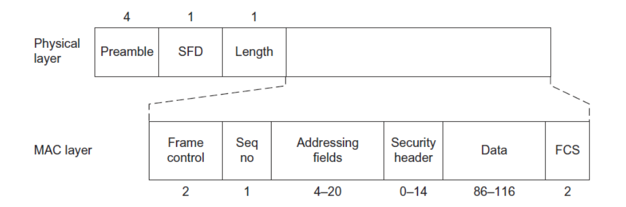

In the worst case, these two layers sum up to 4 (preamble) + 1 (SFD) + 1 (Length) + 2 (Frame control) + 1 (Seq. no) + 20 (Adressing fields) + 14 (security header) + 2 (FCS) = 45 bytes

* The IPv4 adds an overhead of 20 bytes and the TCP protocol also adds 20 bytes more.
* The MQTT has an overhead between 2 and 5 bytes depending on the QoS, we will consider the worst case. The topic “mytopic” is 7 bytes long, and the payload of the MQTT message is 15 bytes (sensor reading data).

**All these sum up to 112 bytes**: 45 bytes (physical and MAC layers) + 40 bytes (TCP/IPv4) + 27 bytes (MQTT) = 112 bytes.

Every time a node wants to send a temperature message, it needs to retransmit a 112 byte frame. This happens ever 5 minutes, so each node should send (112 bytes * 8 bits/byte) / 5 min * 60 s/min = 3 bits/s, considering there are no erros. But, we know that 1 in 5 messages contains errors and needs to be retransmitted, so the real **data rate of each node should be 3 bit/s * 5/4 = 3,75 bits/s.**

**2. DATA STORAGE**

Every node sends 15 bytes of data every 5 minutes. The total size of the data it sends every year is 15 bytes * (24 hours * 60 min/hour)/5 min * 365 days/year = 1.576.800 bytes/year.

The system has 1000 nodes, so the total amount of data to be stored per year is 1.576.800 byte * 1000 nodes = **1.576.800.000 bytes ≈ 1,47 GB/year.**

Nowadays applications store large amounts of data, 1,47GB is a small size of data to store. All the main cloud providers cover this for free:

* Apple iCloud offers 5GB for free: <https://www.apple.com/ie/icloud/>
* Google drive offers up to 15GB for free: <https://www.google.com/drive/>
* Amazon Web Services offers different plans where they cover at least 5GB for free: <https://aws.amazon.com/es/free/storage/>
* Microsoft offers 5GB for free: <https://support.microsoft.com/en-gb/office/how-does-microsoft-storage-work-2a261b34-421c-4a47-9901-74ef5bd0c426>
* Dropbox also offers 5GB for free: <https://www.cbsnews.com/news/dropbox-offers-5gb-of-free-cloud-storage/>